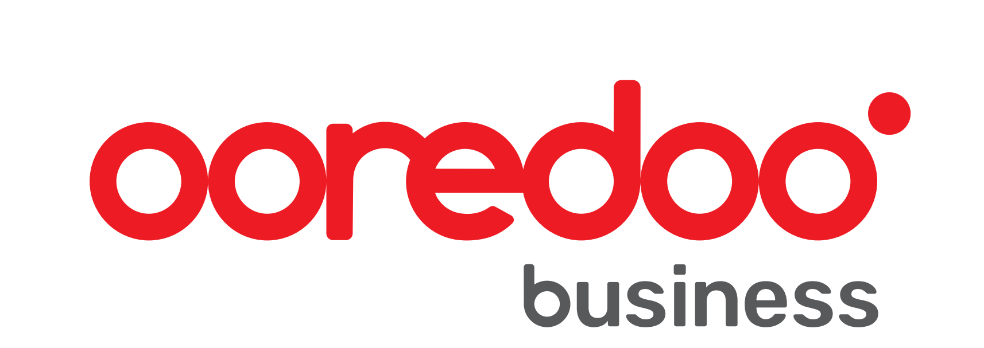

**Intelligent ICT Awards Middle East 2024 – Nomination Form**

The closing date for nominations is Saturday 7th September 2024. Should you need assistance with putting forward a nomination, please contact [eventsteam@lynchpinmedia.com](mailto:eventsteam@lynchpinmedia.com)

Putting forward a nomination is **completely free** and if shortlisted, you **will not** be charged to attend the event.

Not sure which category or award fits your company? Don't worry, we've kept them broad and if you're a vendor, you can nominate an end user that has benefited from your product and both you and them can attend the event.

**Applicant**

|  |
| --- |
| **Name of individual submitting application:** |
| **Contact number:** |
| **Email address:** |

**Nomination**

|  |
| --- |
| **Award category:** |
| **Name of award:** |
| **Name of nominee or organisation:** |
| **Job Title of nominee:** |
| **Workplace of nominee if applicable:** |
| **Number of employees at nominee’s workplace:** |
| **Industry vertical of nominee:** |
| **Website address of nominated organisation:** |
| **How did you hear about the Intelligent ICT Awards Middle East 2024:** |

**Evidence**

Mandatory - This is where we want to know what makes your nominee stand out. To understand the criteria, please visit [www.intelligentictawards.com/middle-east-awards-and-nominations/](http://www.intelligentictawards.com/middle-east-awards-and-nominations/) and scroll to the bottom of the page.

.